**CAPSTONE PROJECT**

**NETFLIX MOVIE RECOMMENDATION ENGINE**

**SUBMITTED**

**BY**

**DHINESH S R**

**Table of Contents**

1. Problem Statement

2. Project Objective

3. Data Description

4. Data Pre-processing Steps and Inspiration

5 EDA

6. Choosing the Algorithm for the Project

7. Model Evaluation and Techniques

8. Inferences from the Same

9. Conclusion

10. References

**1 Problem Statement**

For the purpose of this Project we will be creating one such Recommendation Engine from the ground up, where every single user, based on their area of interest and ratings, would be recommended a list of movies that are best suited for them.

**2 Project Objective**

1. Find out the list of most popular and liked movie
2. Create Model that finds the best suited Movie for one user
3. Find what movies have received the best and wost ratings based on User Rating

**3 Data Description**

Loading Dataset In local System

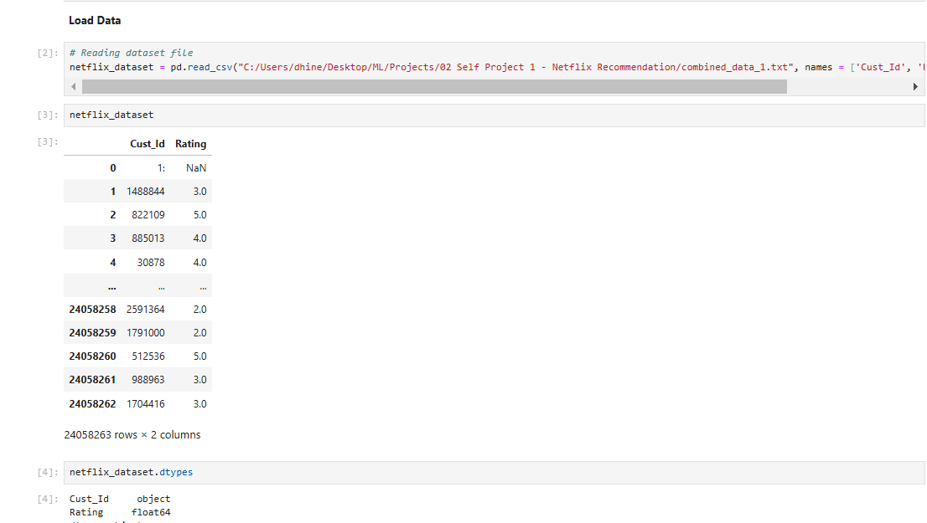

Dataset Info

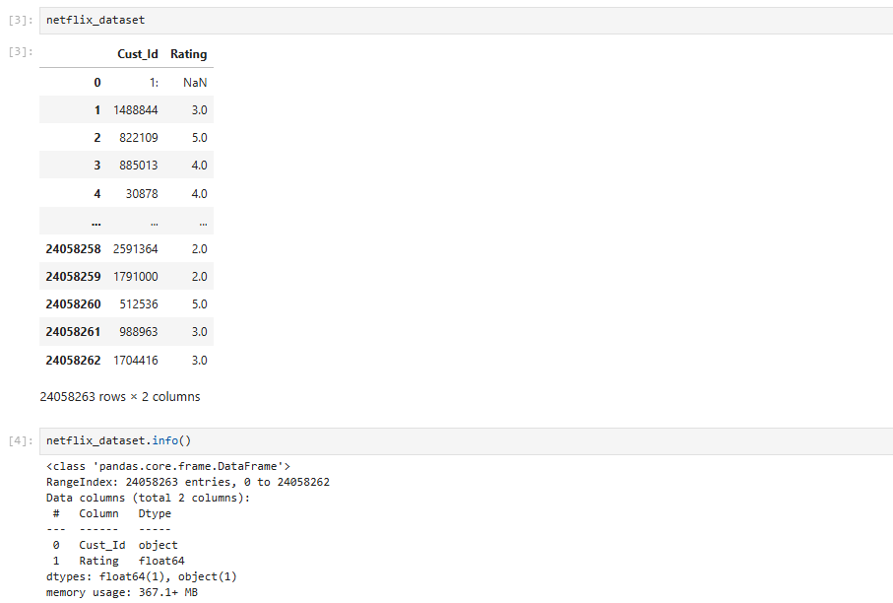

Loading Second Movie Title Dataset and Info

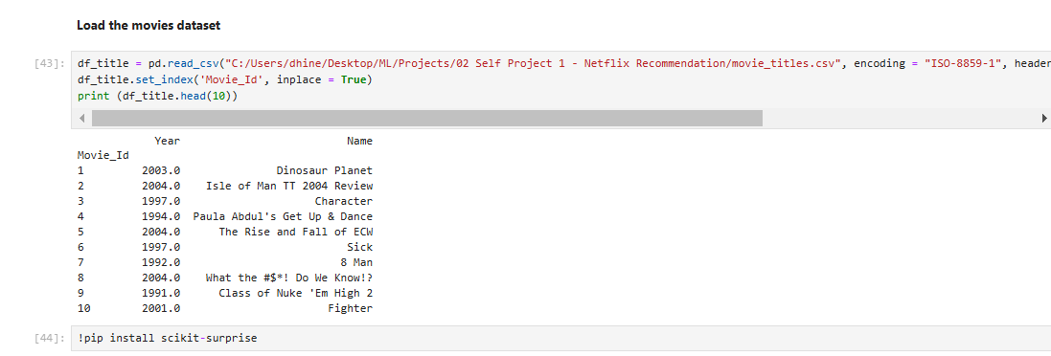

**4. Data Pre-processing Steps and Inspiration**

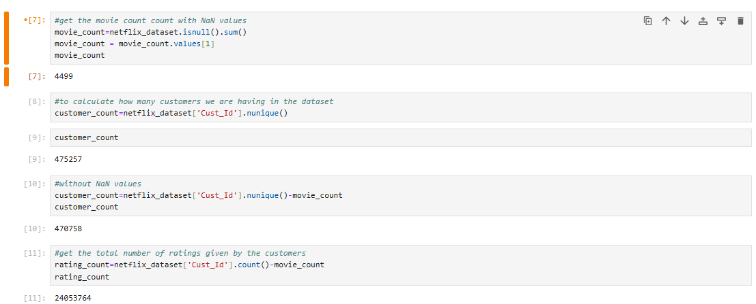



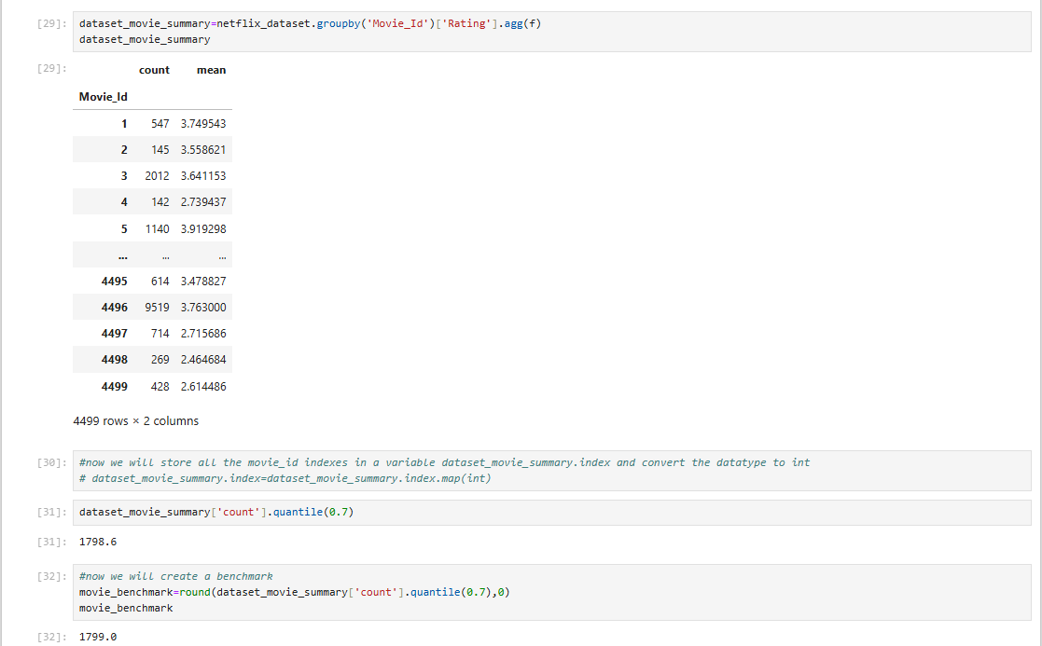

**5 EDA Results**

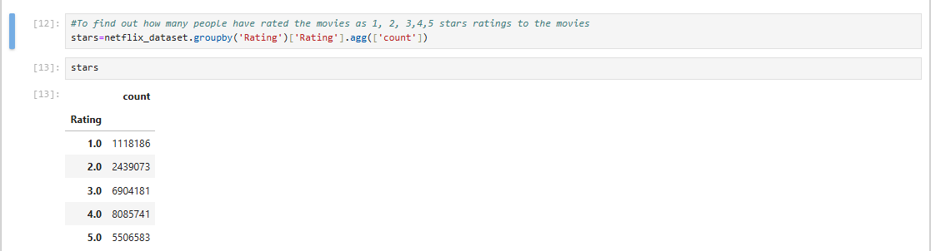

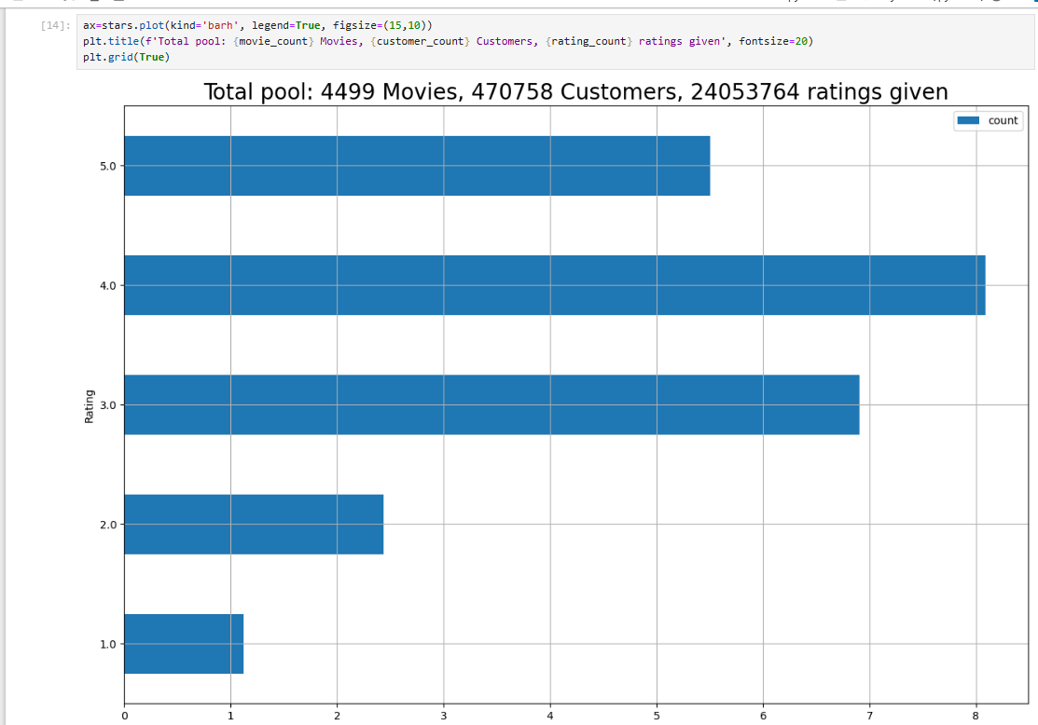

**6. Choosing the Algorithm for the Project**

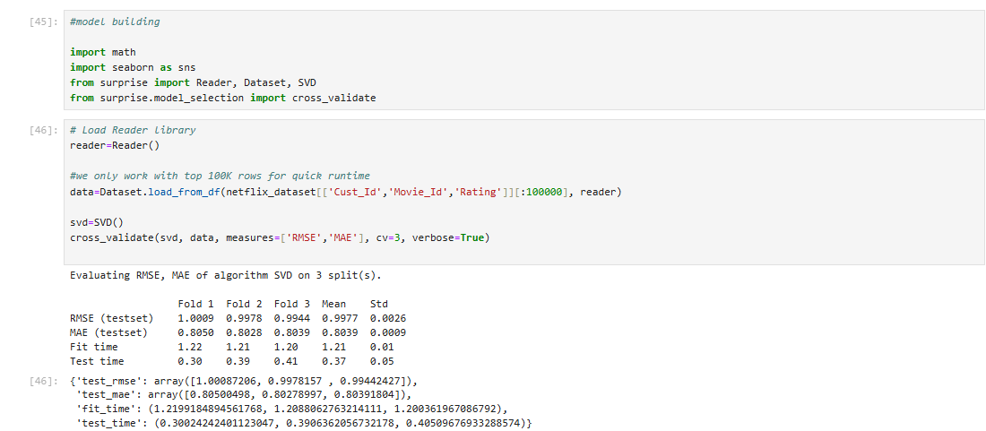

**7. Model Evaluation and Techniques**

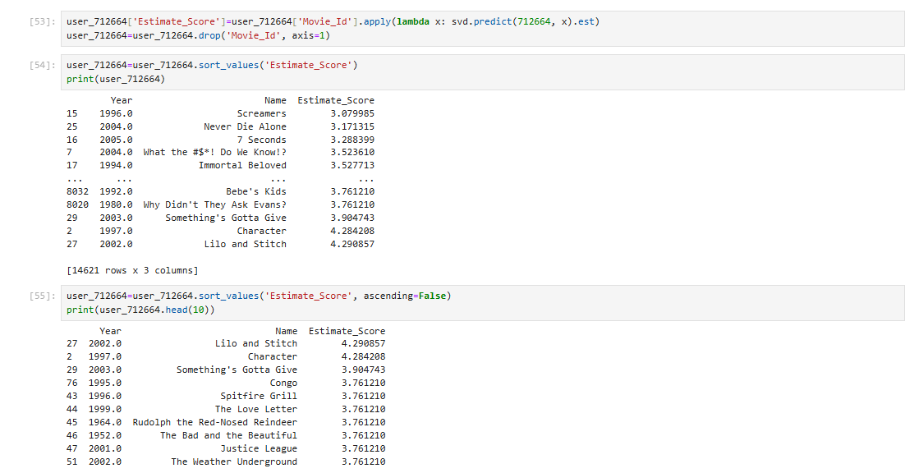

**8. Inferences from the Same**

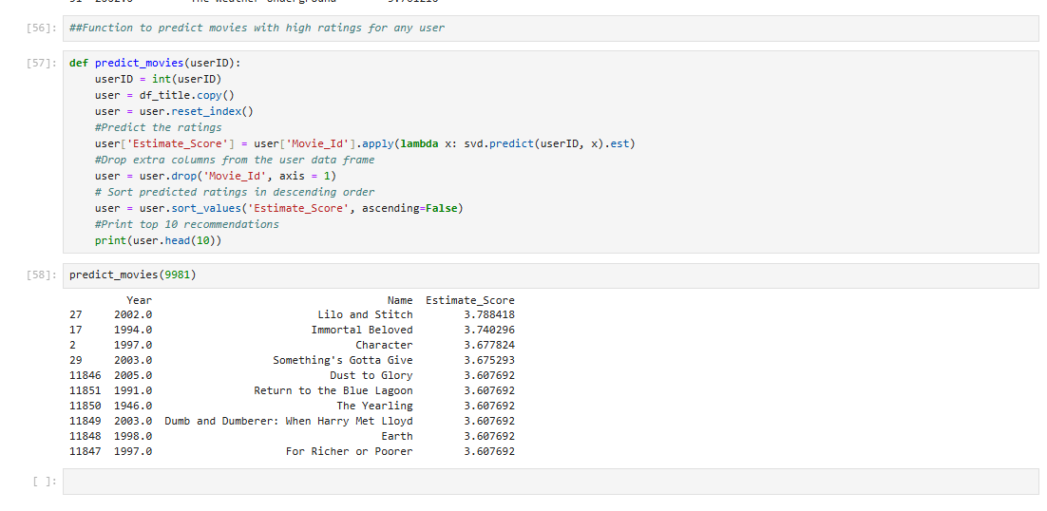

**9 Conclusion**

In conclusion, our Netflix Recommendation Engine using SVD is a promising step towards providing users with more tailored and enjoyable movie recommendations.

**10. References**

* IntelliPaat Recorded Session
* Chat GPT
* Kaggle